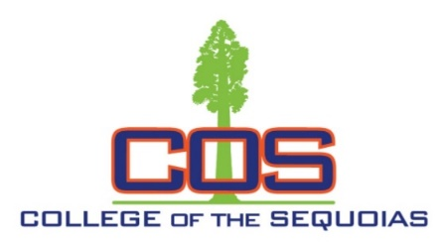
Information Communication Technology
Advisory Meeting Minutes
02/01/2019
- Introductions:
- Brief discussion among advisory members, and attendees: Peggy Yeates (Tulare County), Daniel Baker (Kaweah Delta Medical Center), Tim Torian (Torian Group), Chris Christensen (Western Milling), Michael Niehoff (COS), and Ramyar Alavi-Moghaddam (COS).

2. Next meeting:
- To be held on Friday 08/30/19 12:00 pm at the Vintage Press in Visalia.
3. Since last meeting:
- The A.S. degree in Information Communication Technology has been approved and is part of the two year associate degree programs in the COS catalog.

4. What is going on with current technologies and upcoming projects?

- Chris discussed heavy emphasis on Power Shell knowledge being a key to various system configurations in his environment. Will make an effort to include more practice in this area through the Windows server MCSA track.
- Cloud and Virtualization services are still a big part of every IT environment and will continue to grow in the coming years (VMware, AWS…). Looking at perhaps adding a new course in this area.

5. Internship and job shadowing opportunities, and tours of IT facilities for current and potential students:

- Tulare County, and Western Milling are ready to take on internship students. Will look for suitable candidates throughout this semester and fall 2019.
- Will coordinate with industry partners to setup tours of various IT facilities for student in March, and April 2019.

